
Compsoft Technologies
Bangalore, Karnataka

AN INTERNSHIP REPORT ON
“ STORE MY RESULT ”

BACHELOR OF ENGINEERING

IN

COMPUTER SCIENCE AND ENGINEERING

Submitted by: NAZIA BANU (1KN19CS067)

VANDANA K C (1KN19CS108)

Under the Supervision of: Sumukh S Jadhav

K N S INSTITUTE OF TECHNOLOGY
(Affiliated to Visvesvaraya Technological University and Approved by AICTE, New Delhi)Accredited By NAAC with ‘A’ Grade
ISO 9001-2015 and 14001-2015 certified Institute

Bangalore, Karnataka 560064

2021-2022

ABOUT THE COMPANY

CST is a digital service provider that aims to provide software, designing and marketing solutions to individuals and businesses. At CST , we believe that service and quality is the key to success
We provide all kinds of technological and designing solutions from Billing Software to Web Designs or any custom demand that you may have. Experience the service like none other!

Some of our services include:
- Development - We develop responsive, functional and super-fast websites.
- We keep User Experience in mind while creating websites. A website should load quickly and shouldbe accessible even on a small view-port and slow internet connection.
- Mobile Application - We offer a wide range of professional Android, iOS& Hybrid app development services for our global clients, from a start up to a large enterprise.
- Design - We offer professional Graphic design, Brochure design & Logo design. We are expertsin crafting visual content to convey the right message to the customers.
- Consultancy - We are here to provide you with expert advice on your design and development requirement.
- Videos - We create a polished professional video that impresses your audience.

Table of Contents

Contents Page No.

Table of Contents
Overview of the project 1
About 2
Tools used 3
Implementation 4-25
Snapshots 26-27
Bibliography 28

OVERVIEW OF THE PROJECT

Project Name: STORE MY RESULT
Team Members: NAZIA BANU
VANDANA K C

OVERVIEW:

The technological development and impact of computers and internet on our lives that
has been verified over time affected various sectors of activity. And almost every task
today is being run through computers. Getting information and quickly turning it
into a product that consumers want is the essential key to staying in business and all of
this is done nowadays using computers and applications or information systems. And
the education system is undeniably the backbone of the society, it focuses at preparing
the young talents for the future. However, currently the process of student’s result
management and declaration at the Catholic University of Mozambique, is
performed manually with extensive human intervention, the students’ results are
generated through a spreadsheet application and then printed on a paper, attached to a
wall for declaration and then stored. The current research aims at creating a web
based student result management system, reducing time, effort and improving security.
The methodology adopted for the elaboration of the research is based on qualitative study.
The research results in the development of a multi-user system, based on web technology
with MVC (Model-View-Controller) architectural pattern and developed using
Java programming language with Apache Tomcat Server and MySQL Database
Management System support.

1.Introduction

The impact of computers and internet, on our lives today is probably much more than
we really know. Getting information and quickly turning it into a product that
consumers want is the essential key to staying in business and all of this is done
nowadays using computers and applications or information systems.
And the information systems will continue to change businesses and the way we
live. Many corporate leaders are using technology to manage every aspect of their
organization, from product creation to customer service.
It has brought evolution in almost every field, it changed the ways of teaching,
administration of activities such as e-learning, e-library and online portals where
teachers and students communicate, and sharing of information has never been better.
Student result declaration and management are amongst the most important
activities within a university or any educational institution, since all other activities
depend on it. Hence implementing an information system can be declared a
significance result.
The main objective of this research is to enhance and automate the management and
declaration of students’ results using a computerized system.

  - Problem Definition

Currently, the process of declaring and managing the students’ results at the Catholic
University of Mozambique, is performed manually with extensive human intervention.
The students’ results are generated through a spreadsheet application and
then printed on a paper, attached to a wall for declaration and then stored.
Despite having an application that generates the result, it is not very effective as
the system consumes a lot of time and human resources in performing various tasks, it
is costly, it lacks data security and efficiency. And at present, the institution needs an
advanced and computerized environment. And once implemented, it will minimize all
the problems mentioned.

  - Scope

The study aims at developing and implementing a web-based student result
management system for the Catholic University of Mozambique, replacing the old
manually done paper work and to minimize the security issues and the problems it
possesses.
The proposed is a multi-user system, developed using Java programming
language with Apache Tomcat Server and MySQL DBMS (Database Management
System) support.
The system is confined to and intended for the students. They possess privileges
to check their results after he/she is provided with a specific username and password
for a secure login. The entire system is managed by a system administrator, who
possesses the full control of the system, to read, write and execute the results and to
assign privileges to teachers and students. And the teachers have the privilege to
assign the students’ marks, through which, a result will be generated automatically
and each student will have access to their results only, using their respective account.

  - Research Significance

The computerization of the current system will have an impact on the way the
students access their results and, how it is managed and generated by the institution’s
employees. The system will make the life much easier for the institution as they will
be able to store data much better than how they were able to do earlier.
The students will have a smart management of their results and will be able to
keep track of their progress with an ease of access, from anywhere, anytime and any
device that has an internet connection, and just by entering their respective credentials
provided by the institution. Not only for the students, but for the teachers and the
institution’s employees managing the system as well. They will be able to keep their
data organized and secure.
The system will allow the teachers to grade the students even from home, then
automatically perform the grades calculation, and the students could easily access and
print them. This avoids the teachers from doing all the work manually, and have a
better work quality and management that would reduce time, human effort and errors.

2. Literature Review

According to Freund et al. (2017), nowadays people interact directly with technology
in fields such as education, government, finance, retail, entertainment, health care,
science, travel, publishing, and manufacturing.
And they also state that, educators and teaching institutions use technology to
assist with education. Most equip labs and classrooms with laptops or desktops. Some
even provide computers or mobile devices to students. Many require students to have
a mobile computer or mobile device to access the school’s network or Internet
wirelessly, or to access digital-only content provided by a textbook publisher.
And educators may use a Course Management System (CMS), sometimes called
a Learning Management System (LMS), which is a software that contains tools for
class preparation, distribution, and management. For example, through the course
management system, students access course materials, grades, assessments, and a
variety of collaboration tools.
Many schools offer distance learning classes, where the delivery of education
occurs at one place while the learning occurs at other locations. Distance learning
courses provide time, distance, and place advantages for students who live far from a
campus or work full time.
Referencing Wallace (2015), the LMS is an information system used to track
student progress, and manage educational records. Many offer other features, such as
online registration, assessment tools, collaborative technologies, and payment
processing. They also offer tools for creating or importing content.
And she also states that, people are so accustomed to social networking and other
web applications that it is an easy step to build these tools into an online platform or
environment.
And referencing Wundenberg (2015), LMS characterizes a complex, often web
based software system which pools multiple task specific subprograms under a shared
User Interface (UI).
These subprograms support, for instance:
• Allocation and organization of learning content for different learning scenarios;
• School administration;
• Information management;
• Online school business related communication.

2.1 Learning Management System Features

Dias, Diniz and Hadjileontiadis (2014) state that, LMS Moodle (Modular Object
Oriented Dynamic Learning Environment), a free and open-source platform based on
socio constructivist perspectives developed by Dougiamas in 1999, allows users to
incorporate various resources and functionalities in a modular structure. Additionally,
seen as a Course Management System (CMS), Moodle can be used to manage the
students’ path, to monitor their performance, to create and distribute content, to
organize e-activities, to evaluate, as well as to provide tools for communication,
collaboration and interaction between the peers involved in the educational process.
However, it is important to underline that incorporation of a wide range of
activities in the LMS per se does not seem sufficient to enhance the teaching learning
process. These kind of learning platforms (e.g., Blackboard, Formare, Moodle,
Teleformar, WebCT) should be seen as an opportunity for institutions to develop
learning materials, online courses, tests and evaluations, databases and to online
monitor students’ progress.
Furthermore, Wundenberg (2015) states that, an LMS also has to represent a
number of characteristics to satisfy the stakeholders’ needs:
• User friendly, intuitive design and self-explanatory functionalities;
• Adequacy for the users’ levels of experience and knowledge;
• High system robustness against data-loss or system failure;
• High data security standards;
• Easy accessibility;
• System flexibility for institutions’ individual configurations and concept
adaptations.
According to Foreman (2018), an LMS differs from other information systems
and it has its own features that allows schools and institutions to manage users and
courses and administer the system.
• The user management features of an LMS include user account creation,
authentication, user profiles, and roles and permissions.
• The course management includes managing lessons and assignments, post a
course syllabus, learning goals, and schedule, provide interactive activities such as
surveys, quizzes, and polls, upload and download multimedia course materials,
conduct web conferences, send instructor-student messages and messages among
students and establish student groups.
• The academic features are those that require special permission and, generally,
are not accessible to students. They include class rosters and gradebooks, reports,
analytics and statistics, and tools for developing courses and lessons in the system.
Moreover, the current research focuses on the section where the professors and
students are registered into the system and are enrolled in respective subjects,
allowing the professors, to grade the students and monitor their progress. And allows
the students to view their own progress or results on each enrolled course.

TOOLS USED

Software Requirements

  - Visual Studio Code 2019.

  - Google Chrome or Microsoft Edge of latest version.

  - Front End: HTML, CSS, JS

  - Backend : Php, MySQL, Xampp

  - Linux 7.1 or Windows XP/7/8/10 OS or Mac OS

Hardware Requirements

- Pentium 200-MHz computer with a minimum of 64 MB of RAM (128 MB of RAM recommended).
- Monitor with a refresh rate of at least 40Hz for a smooth GUI experience (optional).

IMPLEMENTATION

A development environment refers to the mix of software tools, methods, and
physical resources that an IT (Information Technology) team uses to create an
information system. It usually is easier to use an IDE (Integrated Development
Environment), which uses built-in tools provided by the software vendor (Tilley &
Rosenblatt, 2017). And for the development of the current system, Eclipse IDE was
used which is a well-known IDE, it is free, open-source, and community-supported.
The implementation or coding of the proposed system was performed using Java
programming language which is based on the object-oriented paradigm. It organizes
the system in modules or classes within their respective packages. And has become a
popular approach not only in the field of programming but for system analysis and
design.
The current system was implemented based on the software architecture standard,
MVC, which describes its three layers. The information flow of this system, using the
MVC standard highlights in the View layer, that is, the client section where
information or resources are requested from the system. The Controller layer is
responsible for receiving the requests and then processing and directing them to the
Model layer in charge of satisfying the request by retrieving the information from the
database. Then it passes the information obtained, to the Controller which delivers the
response to the View and finally displays the information to the client, through the
browser.

SNAPSHOTS

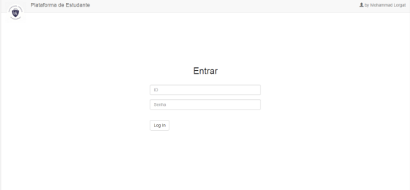

Login Page

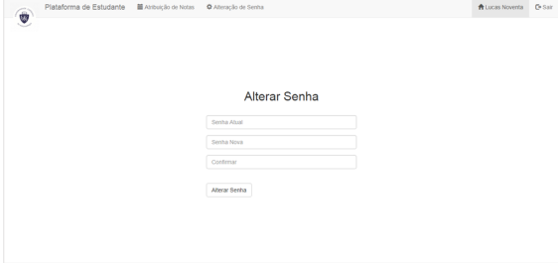
Alter Password Page

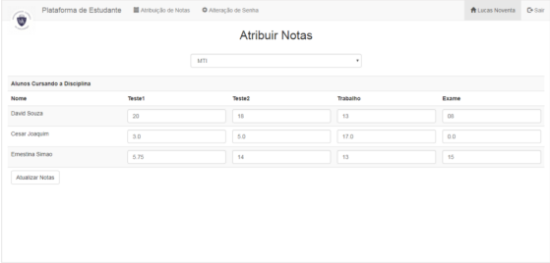
Grades Assigning Page

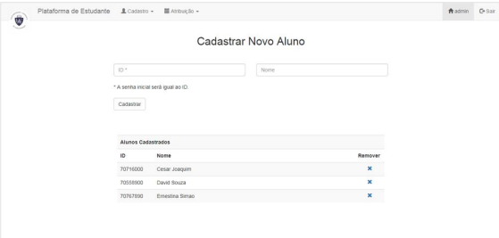

Students Account Management Page

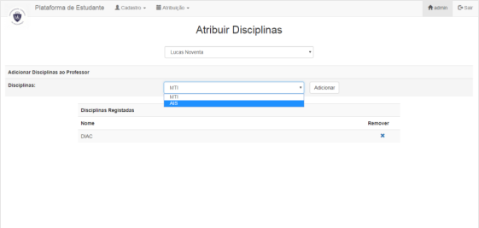
Subject Assigning Page

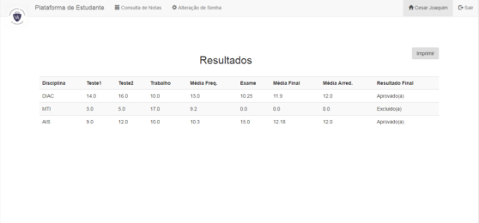
Results Page

BIBLIOGRAPHY

- https://www.w3schools.com

- https://www.geeksforgeeks org

- https://freefrontend.com

- https://css-tricks.com/

- https://www.takeiteasyengineers.com

- https://dev.to/mychi_darko/php-tips-and-tricks-4kpn

